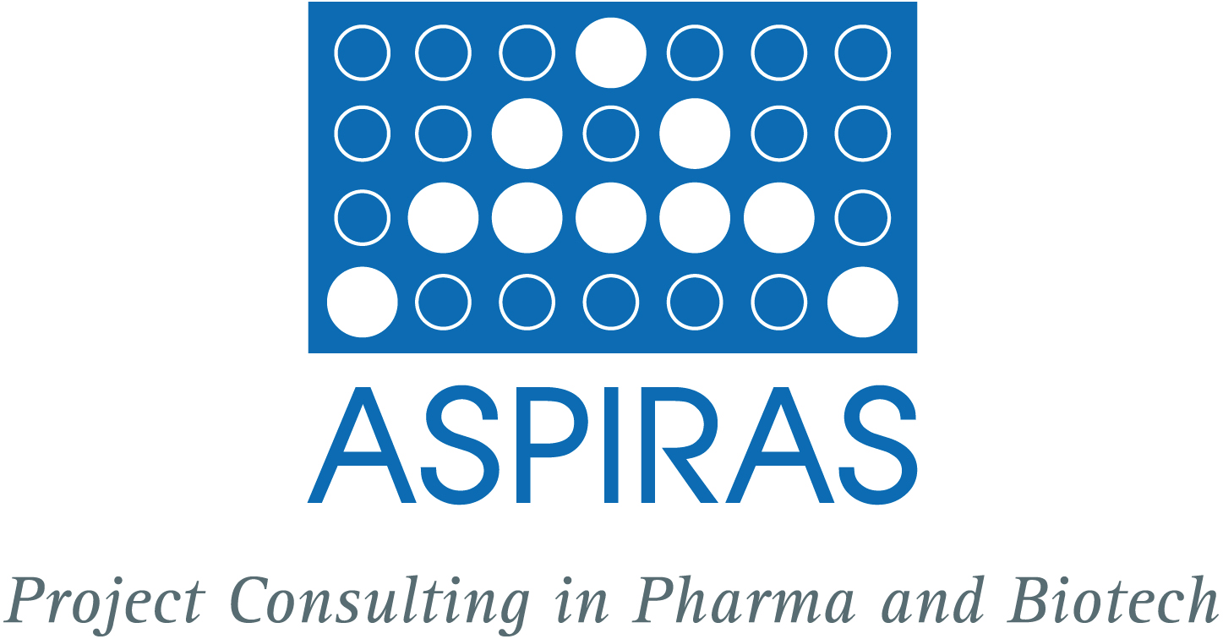

ASPIRAS wishes you a lot of success in spring 2006! What’s new in April 2006?

*******************************************************************************

Economic turnaround for a debt-ridden innovation centre by ASPIRAS consultants

The German consultancy firm Aspiras, Mainz has advised Finzelberg, a specialised supplier of plant extracts, in the takeover of the building of the center of innovation and entrepreneurship (IGZ) in Sinzig, close to Bonn. From April 2006 onwards Finzelberg combines the Science, Sales and Laboratory departments in the modern innovation centre thereby creating 47 high-level jobs in the district.
ASPIRAS (www.aspiras.de) is specialized in consultancy services for the pharma and biotech industry. ASPIRAS took over the management of IGZ Sinzig in April 2005 which was established with federal funds in 2004 and implemented a new strategy. "We are very pleased that we have achieved the take-over by Finzelberg. The centre that worked with a financial deficit so far is now self-supporting," IGZ-managing director Dr Harald Borbe of ASPIRAS said.

*******************************************************************************

Update of our website

For your convenience we have updated our website. More material is now available regarding our services for you. You will know us and our work better after glancing at complete presentations and reading about our contributions to economic and social issues, e. g. supporting young females in their interest in natural sciences. Welcome to ASPIRAS Live! at http://www.aspiras.de/en/seiten/aspiras-live/live.html.

*******************************************************************************

PR service

Since March 2006 there is a new service available in the area of public relations in the ASPIRAS portfolio. We are offering you the complete package in PR ranging from contents for your website and preparing newsletters to targeted press releases to relevant media and online portals. Whether you are intending to broaden your PR spectrum thereby gaining new customers or to inform your current clients about new services of your company – let us discuss the right approach in PR at pauly@aspiras.de.

*******************************************************************************

ORPEGEN Pharma, Heidelberg

At Orpegen Pharma ASPIRAS is supporting the activities in marketing and product sales via connecting the company with relevant potential customers in the pharmaceutical and biotech industry. We are scheduling meetings, attending the client’s presentations and are actively furthering the cooperations.

*******************************************************************************

Take a break!

On the recreational site of ASPIRAS a new photograph and a new citation will enhance your creativity http://www.aspiras.de/en/seiten/break.html.

*******************************************************************************

Challenge us

Just contact us non-committally and tell us your problem. Based on a sound analysis ASPIRAS offers you a coarse concept including a cost estimation. After consultation with the client it provides the following services: project target identification, project planning regarding time, capacity, cost and manpower, project implementation and control and project documentation. ASPIRAS finalises projects effectively and in the agreed upon time frame. Please contact Cathrin Pauly, pauly@aspiras.de.

*******************************************************************************

Cathrin Pauly
ASPIRAS
Project Consulting in Pharma and Biotech
Am Rosengarten 29
D-55131 Mainz

Phone: +49 (0) 61 31 - 99 53 04
Mobile: 0 162 - 615 07 83
Fax: +49 (0) 61 31 - 99 53 05
e-Mail: pauly@aspiras.de
Internet: www.aspiras.de

