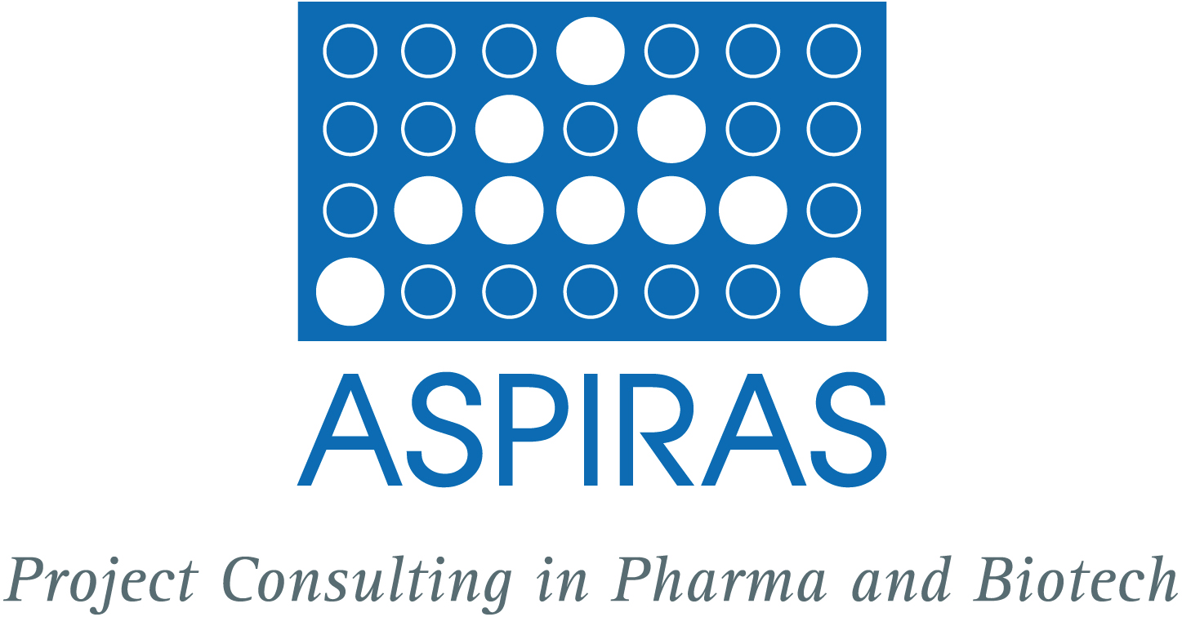

The autumn wind blows around our nose and colorful foliage lines the streets. We greet you with the heralds of the cold season and hope for a nice winter!

*******************************************************************

Literature database – effortless management of publications
In cooperation with the ilexius GmbH, Wiesbaden (yes, there are cooperations beyond the river!), we have developed a bibliographic database that allows you to keep track of the literature of your scientific discipline and manage your own additional literature collections. It gives you quick access to relevant articles and publications. Of course your particular needs and desires will be considered in the development and maintenance of the database.
Arrange an appointment for demonstration with Cathrin Pauly under +49(0)6131-995304 or +49(0)162-6150783, or send an email to pauly@aspiras.de.

*******************************************************************

News of the Initiative ‚Gesundheitswirtschaft Rheinland-PfALZ’

With the establishment or strengthening of regional round tables, the initiative for health care management aims to bring forward the network of local health economic actors. The round tables will be used to support regional or industry-specific networking and profiling of the health economy in the context of independent initiatives or preparation of joint projects under the Initiative for Health Economics Rheinland-Pfalz.
The relevant actors in the development and implementation of later projects are included as far as possible. Four round tables will take place this year under the auspices of the Economic Development of the City of Mainz. Focal point is the cooperation between science and industry.

*******************************************************************

Workshop Alliance Management
Create productive partnerships in Life Science

There was given support in forming vibrant and successful cooperations at the workshop "Alliance management", to which we invited especially department heads and managers from the pharmaceutical and biotechnology industry along with n-tier services. Workshop participants learned about organizational aspects of a professional alliance management, provided by ASPIRAS in the context of the long years of experience in project partnerships. Standardized computer-based tools improve cooperation between the responsible members of the various cooperation or alliance partners - relevant information and documents are directly and clearly available. "Now I know what I missed the last few years!" - this praise of a visitor we take as an incentive - the next workshops are being planned.

If you are interested in a workshop sign up under +49(0)6131-995304 or +49(0)162-6150783, or send an email to pauly@aspiras.de. Once we fixed the new date we will inform you.

*******************************************************************
MORE SAFETY in INNOVATIONS AND INVESTMENTS – ‚the ASPIRAS CHALLENGE’

To secure the future of your business, you plan new projects, think about a spin-off from your existing business and perhaps look for the financing of these innovations. It needs a thorough examination, what will be the expected profits, when to expect the receipt of payments and whether you need additional capital. The basis for these plans is a sound project or business valuation, assessment of competition and the relevant markets.
ASPIRAS collects and structures relevant data and tests your project on economic success using scenarios.

Please get in touch with us under +49(0)6131-995304 or send an email to pauly@aspiras.de, if you would like to learn more about these services.

*******************************************************************

upcoming events

To keep our know-how up to date and to keep in touch with our clients and business partners we will be present at the following events in the near future:

- PMI Frankfurt Chapter Dinner, Project Management Institute (PMI), 29. November in Frankfurt

- Clusterconference of the Clusters for Individualised ImmunIntervention, 1. December in Mainz

- PLCD-autumn meeting, 2./3. December in Hannover

If you wish to participate in one of the events and use the chance of one-to-one interviews, please arrange a date by calling +49(0)6131-995304 or +49(0)162-6150783 or by sending an email to pauly@aspiras.de.

*******************************************************************

good to know

The Year of Biodiversity is drawing to a close. At the World Summit on Sustainable Development in Johannesburg 2002, the present countries set the goal to slow down biodiversity loss significantly by 2010, in the face of the accelerated species extinction and the loss of habitats. Previous measurements showed a further loss of biodiversity, but there are positive trends in the conservation areas, whose size has doubled in the last 20 years to 12% of the land areas. Also, the water quality has improved significantly. The greatest success is likely to be raising awareness of the need for action.

More information under http://www.cbd.int

*******************************************************************
TAKE A BREAK!

Allow yourself a time off and take a creative break. For this purpose we’re providing a wise saying which is accompanied by a seasonally adequate photograph and relaxing music:
http://www.aspiras.de/de/seiten/break.html

*******************************************************************

CHALLENGE ASPIRAS

Just contact us without obligation and discuss your topics and your list of questions. Based on a sound analysis, ASPIRAS offers you a coarse concept including a cost estimation. After consultation with the client ASPIRAS provides the following services: project target identification, project planning regarding time, capacity, cost and manpower, project implementation and control and project documentation. ASPIRAS provides the project results effectively and in due time.

Please contact Cathrin Pauly

*******************************************************************

CANCEL THE NEWSLETTER?

You wish to cancel the order for ASPIRAS-newsletters coming out four times a year? Send an empty mail with the subject “cancel the newsletter” to pauly@aspiras.de. We immediately take you from the recipients list.
We would of course appreciate to hear about the reason for the cancellation.

*******************************************************************

CONTACT & COPYRIGHT

Cathrin Pauly
ASPIRAS Project Consulting in Pharma and Biotech GbR
Am Rosengarten 29
D-55131 Mainz

Phone: +49 (0) 6131 - 99 53 04
Mobile: +49 (0) 162 - 615 07 83
Fax: +49 (0) 6131 - 99 53 05
E-Mail: pauly@aspiras.de
Internet: www.aspiras.de

© 2010 by ASPIRAS - Project Consulting in Pharma and Biotech GbR

You may forward the ASPIRAS Newsletter to your friends and colleagues.

