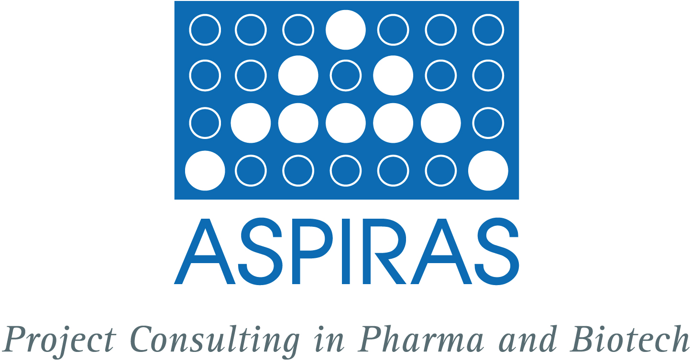

In sunny September we wish you a good start after the holidays and a successful business finale for the year!

*******************************************************************

sales force and use of convenient ordering and Distribution systems

We are in contact with a German enterprise active in the market for twenty years, which now makes available his sales services for the promotion of OTC products to other firms. This sales force is well-established among both general practitioners and specialized physicians. In addition, the use of the well-established ordering and distribution system is offered. Following a recommendation by the doctor the customers order by order form and the products will be delivered to them.
This promotion resource may give some of your products not being in the focus of sales activities a fresh impetus and maximize the potential of these products. The ordering system is a plus contributing to the customer’s comfort.
If you would like to know more about this concept please call 0049-6131-995304, 0049-162-6150783 or send an email to pauly@aspiras.de.

*******************************************************************

Laugh again!

There are some new funny stories for you on our recreation page – unfortunately only in German - at http://www.aspiras.de/de/seiten/break.html.

*******************************************************************

wanted: proposals for the initiative ‚Gesundheitswirtschaft Rheinland-Pfalz‘

ASPIRAS was involved in the development of the concept of ‚Gesundheitswirtschaft Rheinland-Pfalz‘. Now that project applications were called for we would like to submit proposals till October 31, 2009 together with interested companies. The following topics are of interest for us as a service provider in the field of pharma and biotechnology: The topic „Research and Development & Innovation“ represents the sub-markets, which significantly influence the development of the healthcare industry as a result of its high potential for innovation. These are essentially all health-related fields of research and development (pharmaceutical, biotechnology, medical and gerontological technology, environmental technology) as well as the health trade professions.

The topic „Process innovations in the health and care facilities“ concentrates on the central issues of healthcare management. This in particular concerns the use of process innovations and new possibilities of teamwork within and between the submarkets. These are basically the fields of hospitals and surgeries, pharmacies, care facilities etc., as well as the use of novel potentials in medical data/E-health and logistical services for the healthcare sector.

If you have ideas for projects concerning these two topics and perhaps even are in contact with corporate partners, then please get in touch with us at pauly@aspiras.de or via telephone (0049-6131-995304 or 0049-162-6150783).

*******************************************************************

Gaining primary data – conduct and analysis of surveys

The spectrum of ASPIRAS’ methods for opinion research, the identification of an actual need or the acceptance of new products includes the conduct and analysis of surveys. Based on our experience in project management, we safeguard a target-oriented performance of the surveys and ensure an evaluation according to plan. Adequate tools and models for numerical analysis of the data are available at ASPIRAS. A project consists e. g. of the following steps:

  - design of the query mode (questionnaire, type of contact with interviewees, etc.)
  - gathering and validation of the contact details of interviewees
  - conduct the interviews (once or several times)
  - analysis of collected data using statistical methods
  - professional presentation of data and results
  - compilation of a final report

If you are interested in a presentation on the topic, please contact us at pauly@aspiras.de.

*******************************************************************

management of investigational products for clinical studies

If you are interested in the area of the investigational products‘ management, we will be happy to get you in touch with an experienced partner. The services of our partners include secondary packaging, temperature-regulated (-25 °C to 190 °C) high-security transportation, import, export, production and storage of investigational products and narcotic substances in accordance with national and international laws and guidelines (AMWHV, AMG, BtMG, GenTG, cGMP, GCP, GSP and others). Particular expertise exists in the field of innovative therapeutics and regenerative medicine.

If you want to know more about these services, please contact us by telephone under 0049-6131-995304, 0049-162-6150783 or email to pauly@aspiras.de.

*******************************************************************

upcoming events

To keep our know-how up to date and to keep in touch with our clients and business partners we will be present at the following events in the near future:

Biotechnica 2009, 06.- 08. Oktober 2009 in Hannover (www.biotechnica.de)

Tag der Technologie 2009, 26. Oktober 2009 in Mainz, topic Biotechnology: "Life – Environment“ (http://www.tagdertechnologie.rlp.de/)

BIO-Europe, 2. – 4. November 2009 in Wien (http://www.ebdgroup.com/bioeurope/)

PharmaForum 2009, 3. November 2008 in Frankfurt (http://www.pharmaforum-sw.de/)

MEDICA, 18. – 21. November in Düsseldorf (http://www.medica.de).

If you are also participating in one of the events please arrange a date by calling 0049-6131-995304 or by sending an email to pauly@aspiras.de.

*******************************************************************

Social Software in companies - opportunities and Risks for knowledge management

As part of his thesis "Enterprise 2.0 - Social Software in the Enterprise - Opportunities and Risks for knowledge management" Marcel Sehr (University of Applied Sciences Würzburg-Schweinfurt) investigated the suitability of social software to support the knowledge management process within companies. The problem areas of knowledge generation, knowledge distribution and utilization of knowledge are pointed out. Prerequisite for successful use of the software is an appropriate corporate culture and employees which are motivated to use tools for knowledge management. Marcel Sehr empirically found that social software is a suitable tool for knowledge management and is already used by large companies. However, small and medium-sized enterprises have to catch up in this area.

If you are interested in seeing the full study you can either contact us at Pauly@aspiras.de or Marcel Sehr directly at m.sehr@gmx.de.

*******************************************************************

good to know

The Federal Ministry for Education and Research (BMBF) took stock for the implementation of the European Year of Creativity and Innovation 2009 in Germany referring to around 200 events and 60 long-term projects. In relation to other European countries, Germany has a particularly large number and wide variety of events in the program. The aim of the year is the demonstration of creativity and innovation as important factors for the development of personal, professional, social and entrepreneurial skills. The European Commission has selected nine excellent projects from Germany, which are presented on the website
(http://create2009.europa.eu/projects/participating_countries/deutschland_germany.html).
One of the projects is the "House of Little Scientists" (http://www.haus-der-kleinen-forscher.de/), which shall create a steady flow of young scientists in the life sciences.

*******************************************************************

TAKE A BREAK!

Allow yourself a time off and take a creative break. For this purpose we’re providing a wise saying which is accompanied by a seasonally adequate photograph and relaxing music: http://www.aspiras.de/de/seiten/break.html

*******************************************************************

CHALLENGE ASPIRAS

Just contact us without obligation and discuss your topics and your list of questions. Based on a sound analysis, ASPIRAS offers you a coarse concept including a cost estimation. After consultation with the client ASPIRAS provides the following services: project target identification, project planning regarding time, capacity, cost and manpower, project implementation and control and project documentation. ASPIRAS provides the project results effectively and in due time.
Please contact Cathrin Pauly.

*******************************************************************

CANCEL THE NEWSLETTER?

You wish to cancel the order for ASPIRAS-newsletters coming out four times a year? Send an empty mail with the subject “cancel the newsletter” to pauly@aspiras.de. We immediately take you from the recipients list.
We would of course appreciate to hear about the reason for the cancellation.

*******************************************************************

CONTACT & COPYRIGHT

Cathrin Pauly
ASPIRAS Project Consulting in Pharma and Biotech GbR
Am Rosengarten 29
D-55131 Mainz

Phone: +49 (0) 6131 - 99 53 04
Mobile: +49 (0) 162 - 615 07 83
Fax: +49 (0) 6131 - 99 53 05
E-Mail: pauly@aspiras.de
Internet: www.aspiras.de

© 2009 by ASPIRAS - Project Consulting in Pharma and Biotech GbR

You may forward the ASPIRAS Newsletter to your friends and colleagues.

