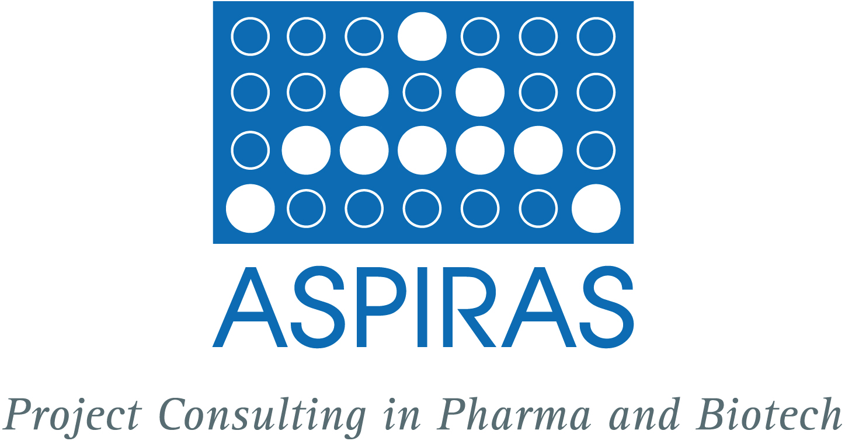

ASPIRAS wishes you a lot of success in autumn 2005! What’s new in October 2005?

*******************************************************************************

Starting activities in nanobiotechnology

Since summer 2005 Cathrin Pauly is a member of the board of NanoBioNet (http://www.nanobionet.de), the interdisciplinary network of excellence in nanobiotechnology. Nanobiotechnology is a cross-disciplinary technology combining elements of both nano- and biotechnology thereby establishing methods by which physiologically safe and biocompatible materials and surfaces can be developed for use in biology, medicine, medicinal technical applications, cosmetics and food technology.

*******************************************************************************

New service profiles for download on our website

After log-in to the ASPIRAS club at (www.aspiras.de/de/seiten/club/club.html) you will find several profiles of our services under ‚ASPIRAS material/download‘. The profiles, currently only available in German, are regarding the following issues:
- Portfolio analysis
- Outlicensing
- Adding competence
- Start-up companies
- Business planning
- Financing
- Interim management
We are keen to provide to you these and other services. Let ASPIRAS convince you with performance!

*******************************************************************************

Pharmacert – An offer in co-operation with TÜV Cleancert GmbH/TÜV SÜD Group

TÜV Cleancert GmbH TÜV SÜD Group is offering together with ASPIRAS a full range of services for pharma, biotech and medical technology companies. From project idea via clinical studies to production and marketing we are safeguarding the quality of products and projects, we are ensuring productivity and take care of GMP requirements in manufacturing. Ask for more information about Pharmacert at pauly@aspiras.de.

*******************************************************************************

Letters of Excellence
After the end of a project we are often receiving letters of excellence from satisfied clients which you can view at http://www.aspiras.de/de/seiten/projektbeispiele.html.

*******************************************************************************

Technopharm - International Trade Fair for Life Science Process Technologies

Visit us at the Technopharm in Nürnberg from October 11 until October 13, 2005 at our booth no. 106 in hall 12.0. Schedule your meeting date with us at pauly@aspiras.de.

*******************************************************************************

Take a break!

On the recreational site of ASPIRAS a new photograph and a new citation will enhance your creativity http://www.aspiras.de/en/seiten/break.html.

*******************************************************************************

Challenge us

Just contact us non-committally and tell us your problem. Based on a sound analysis ASPIRAS offers you a coarse concept including a cost estimation. After consultation with the client it provides the following services: project target identification, project planning regarding time, capacity, cost and manpower, project implementation and control and project documentation. ASPIRAS finalises projects effectively and in the agreed upon time frame. Please contact Cathrin Pauly, pauly@aspiras.de.

*******************************************************************************

Cathrin Pauly
ASPIRAS
Project Consulting in Pharma and Biotech
Am Rosengarten 29
D-55131 Mainz

Phone: +49 (0) 61 31 - 99 53 04
Mobile: 0 162 - 615 07 83
Fax: +49 (0) 61 31 - 99 53 05
e-Mail: pauly@aspiras.de
Internet: www.aspiras.de

